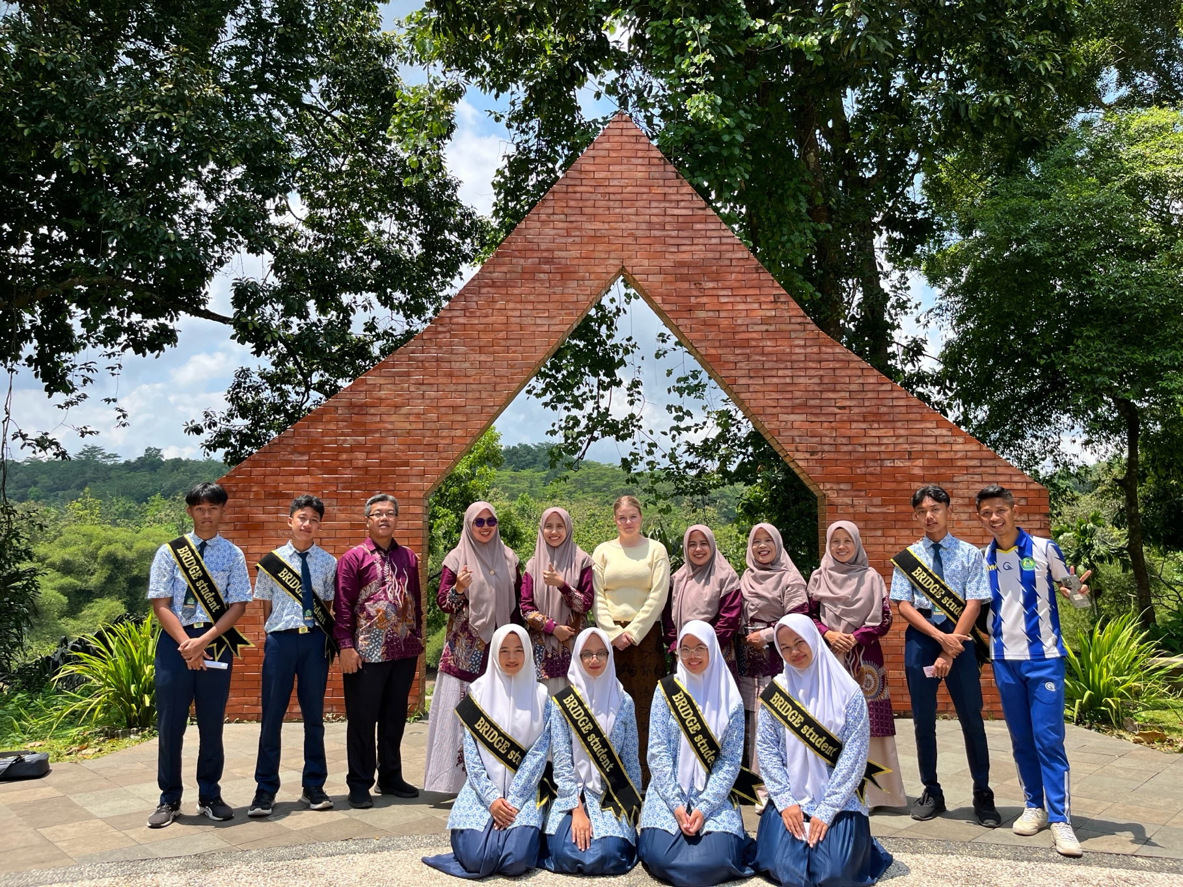
z

Australia-Indonesia BRIDGE School Partnerships Program
2026 SCHOOL SELECTION INFORMATION FOR AUSTRALIAN SCHOOLS


The Australia-Indonesia BRIDGE School Partnerships Program is supported by the Australian Government Department of Foreign Affairs and Trade (DFAT) and implemented by Asialink Education at The University of Melbourne.

Contents

Contents 2
About the Australia-Indonesia BRIDGE School Partnerships Program 3
BRIDGE Program Information 3
Program goal 4
Program outcomes 4
Program Funding 4
Australian Institute for Teaching and School Leadership (AITSL) Standards 5
Alignment to Australian Curriculum 5
DFAT Cross-Cutting Priorities 5
Applying for Indonesia BRIDGE in 2026 6
2026/2027 BRIDGE Program Dates for Australian Schools 7
BRIDGE Grant Opportunities 9
Next steps 9


About the Australia-Indonesia BRIDGE School Partnerships Program

The BRIDGE Program connects Australian and Indonesian schools in a bilateral school partnership. BRIDGE establishes school-to-school relationships, provides teacher professional learning program (online, in person and in country immersion) and connects students through global classroom activities.
Since 2008, the Australia-Indonesia BRIDGE School Partnership Program has established 253 school partnerships and provided professional learning to 953 teachers across Australia and Indonesia. Between 2026 – 2029, an additional 30 school partnerships will be established.
This program is funded by the Department of Foreign Affairs and Trade, Australian Government and managed by Asialink Education, University of Melbourne.

BRIDGE Program Information

Key program commitments
- Participate in hybrid professional learning with your Indonesian partner school from May to August 2026.
- Participate in an in-person professional learning program to be facilitated in an Australian capital city (location to be confirmed based on selected schools) on 21 – 23 August 2026.
- Host two Indonesian educators from 24 – 28 August 2026 at your school and in homestays as part of the school visit / homestay program immersion program.
- Participate in in country immersion and partner school visit program in Indonesia, January 2027.
- Facilitate global classroom activities with partner school.
Location
In 2026, the priority locations in Australia are Western Australia, Northern Territory and Tasmania. In Indonesia the provinces are East Java, Jakarta, East Kalimantan, Central Java, North Sumatera and South Sumatera.

Curriculum
Participation in the BRIDGE Program is open to teachers from across all learning areas. BRIDGE is not restricted to schools or educators that teach Bahasa Indonesia.

Program inclusion
In 2026, 10 Australian schools will be selected
- 7 new schools will be matched with an Indonesian school. (2 teachers to be nominated)
- 3 BRIDGE schools that have previously been involved and have inactive partnerships will be re partnered with an Indonesian school. (1 teacher to be nominated)

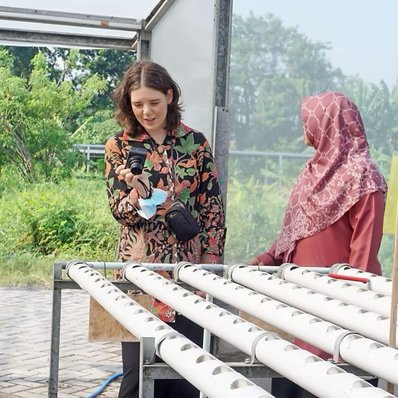
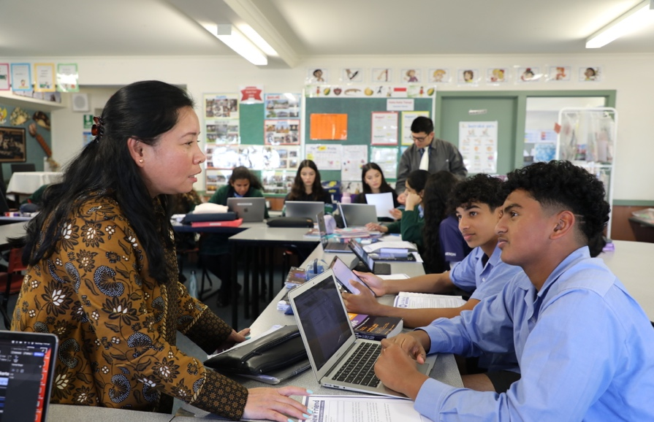

“For me every aspect of the school visit was extraordinary. Being able to visit the school in person, meet the students, teachers and parents was an invigorating experience… Overall, it has reinforced how important our partnership is and how effective and useful it can be to broaden our students' and teachers' intercultural understanding.”
2024 AUSTRALIAN BRIDGE TEACHER

Program goal
- Support stronger people-people relationships through enhancing educators’ skills and mutual understanding

Program outcomes
- Improved pedagogical skills and confidence of participating educators
- Strengthened cooperation between participating educators in Australia and Indonesia engage in enduring and impactful relationships

Program Funding
The BRIDGE Program covers the following participation costs:
Indonesian teacher school visit / homestay in Australia
- Return flights and accommodation for the Australian teacher to the Australian city where the in-person professional learning will take place (location to be determined).
- A per diem for the host / teacher hosting the Indonesian teacher in their home to support home stay program. In 2025 this was $300 for each Indonesian teacher hosted.
.
Australian teacher school visit in Indonesia
- International flight to Indonesia (return) departing from the nearest Australian international airport.
- Accommodation in Indonesia
- Group meals
- Ground transport
- Per diem for Australian teachers to pay for: e visa, international roaming package of their choice, meals during school visit program, incidentals. In 2025 the per diem was $350.
- Guest Travel insurance for Australian teacher provided through the University of Melbourne.
BRIDGE Partnership Grants
- Opportunity to apply for the BRIDGE grants program upon completion of the program (Please note the grants program is a competitive process and therefore applying does not guarantee grant support).

The Australia-Indonesia BRIDGE School Partnerships Program does not cover costs related to:
- Teacher replacement costs for program participation
- Time in lieu costs for Australian teachers

Australian Institute for Teaching and School Leadership (AITSL) Standards
The BRIDGE Professional Learning Program has been designed to address the following AITSL Standards
1.3 Students with diverse and linguistic, cultural, religious and socioeconomic backgrounds
2.6 Information and Communication Technology (ICT)
3.4 Select and use resources
6.3 Engage with colleagues and improve practice
7.4 Engage with professional teaching networks and broader communities

Alignment to Australian Curriculum
- All learning areas
- Cross Curricular Priority: Asia and Australia’s Engagement with Asia and Sustainability
- General Capabilities: Intercultural Understanding; Digital Literacy, Critical and Creative Thinking

DFAT Cross-Cutting Priorities
The Department of Foreign Affairs and Trade have identified several cross-cutting priorities that are integral to international development programs.
Gender equality, disability and social inclusion (GEDSI). DFAT is committed to promoting gender equality and ensuring that individuals with disabilities are included in all aspects of development.
Climate Action: DFAT is focused on identifying and addressing climate risks and promoting climate action. The Initiative will also support projects which reflect and embed Australia’s approach to First Nations engagement.

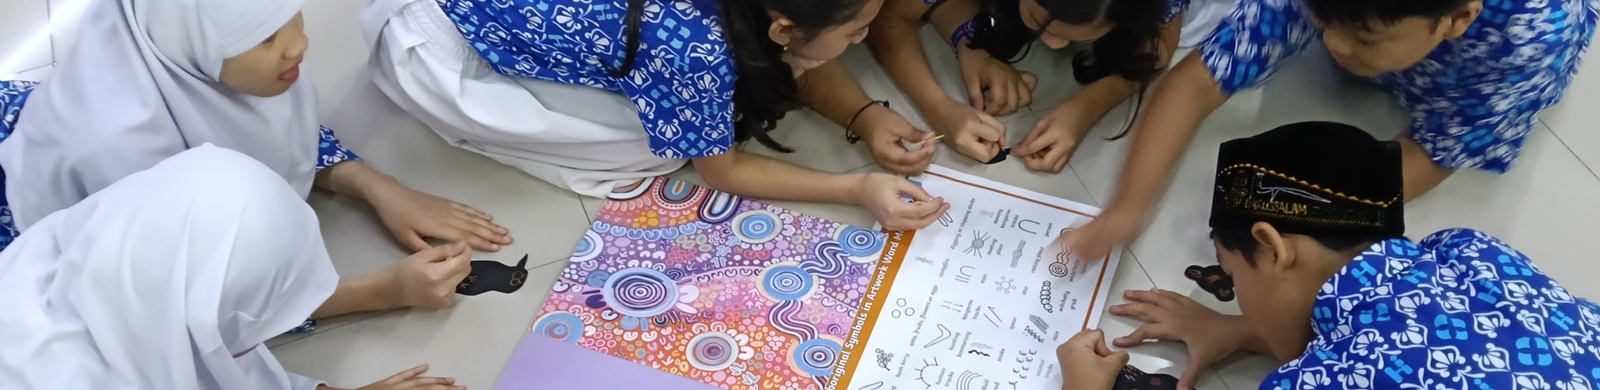

Applying for Indonesia BRIDGE in 2026
The BRIDGE School Partnerships Program selection process is managed by Asialink Education. Australian school applications will be ranked according to the quality of school and teacher responses in the application form. Final school selection also takes into consideration matching Australian schools with Indonesian schools.
School Eligibility Requirements |  | School Selection Criteria
- Be a registered Australian primary or secondary school.  - Located in Western Australia, Tasmania or the Northern Territory.  - Nominate at least one (and a maximum of two) teacher to represent their school and engage with the matched Indonesian partner educators for two years.  - Commit to hosting two Indonesian partner teachers within the school community for the duration of the six-day school visit/homestay program. |  | - Clear vision of the benefit to your school from participation in the BRIDGE Program.  - Have an interest in and commitment to a partnership with an Indonesian school.  - Leadership supports and enables teachers to participate in BRIDGE professional learning programs.  - Have reliable internet access and basic IT infrastructure sufficient to participate in regular virtual exchanges and online professional learning.  - Priority consideration may be given to women-led schools in line with DFAT priority.  - Outline how your school supports students with disabilities and addresses social inclusion.
Teacher Eligibility Requirements |  | Teacher Selection Criteria
- Be a qualified teacher in Australia and hold a Bachelor’s degree or equivalent.  - Currently employed at the applying school (ongoing or fixed-term contract).  - Endorsed by the school principal to participate in the program. |  | - Demonstrate a clear and sustained commitment to establishing and maintaining a professional partnership with an Indonesian teacher.  - Commitment to full participation in all BRIDGE program components (online, in person and immersion).  - Capacity to facilitate student learning online activities with Indonesian partner school.  - Demonstrate digital communication and collaboration skills.  - Ability to share pedagogical practices with Indonesian partner school/teacher.

2026/2027 BRIDGE Program Dates for Australian Schools
Date | Event
9 February 2026 | Australia Indonesia BRIDGE Program applications open
16 February 2026  17 February 2026  18 February 2026 | Online Information sessions on BRIDGE Program facilitated  Time: 5:30pm AEST – 6:30pm AEST (Same time each day)  Register here:  Registration link: https://unimelb.zoom.us/meeting/register/GPznwCfOSpaYPJIzTB_dfA
13 March 2026 | Australian school applications for 2026 Indonesia BRIDGE Program close
Late April 2026 | Australian schools notified of their participation
12 May 2026 | Virtual welcome ceremony for 2026 Australia Indonesian BRIDGE School Partnerships
18 -26 May 2026 | 1-1 Australia Indonesia partnership meetings supported by Asialink Education
2 – 5 June 2026 | Indonesian teachers participate in a four-day Pre-Departure Training program in Jakarta in preparation for travel to Australia.
June – August 2026 | Asialink Education work with Indonesian teachers to obtain travel documentation (passports, visas and Working with Children Checks)
August | Planning for Australian teachers travel to Indonesia (government travel approvals submitted where required.)
20 – 30 August 2026 | 20 – 23 August Australian teachers travel to an Australian city for two-day joint professional learning program with Australian and Indonesian educators.  - Cultural Immersion  - Building relationships  - Design thinking  - Climate change  23 – 28 August Australian teachers travel to home city with Indonesian partner teacher and host five-day school visit and homestay program.  28 – 30 August Afternoon / evening of 28 August, Indonesian educators travel to an Australian capital city for debrief program and departure to Indonesia on 30 August
September 2026 | Continue to build on partnership establishment activities and explore facilitation of a range of Global Classroom student activities supported by Asialink Education
14 – 24 January 2027 | Australian teachers travel to Indonesia  - 3-day cultural immersion program in Jakarta  - 5-day school visit  - 1 day Program debrief
February 2027 onwards | Continue to collaborate with Australian BRIDGE partner school  Apply for BRIDGE Grants  Access professional learning programs  Access Asialink Education global classroom projects
Please note that dates are subject to change

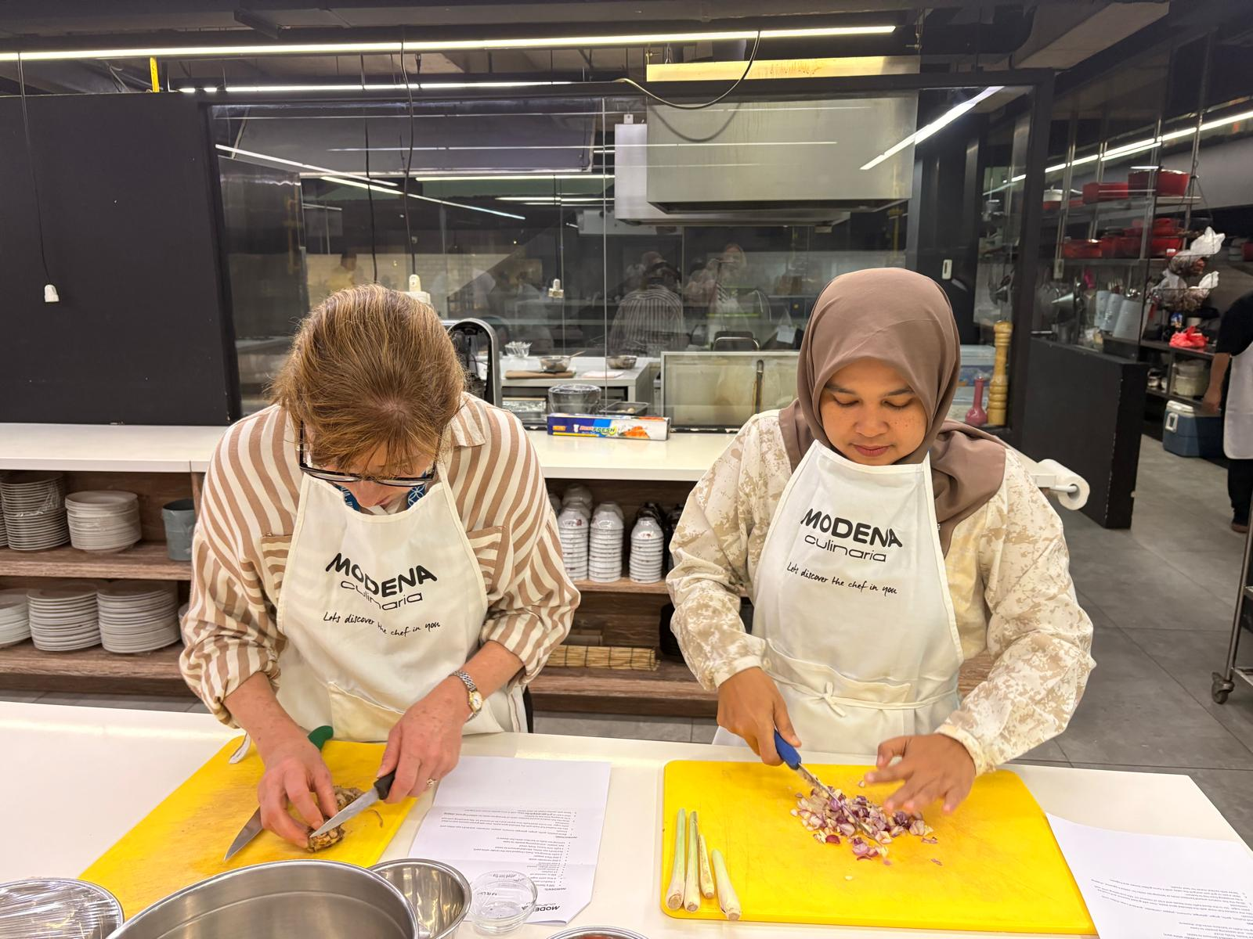
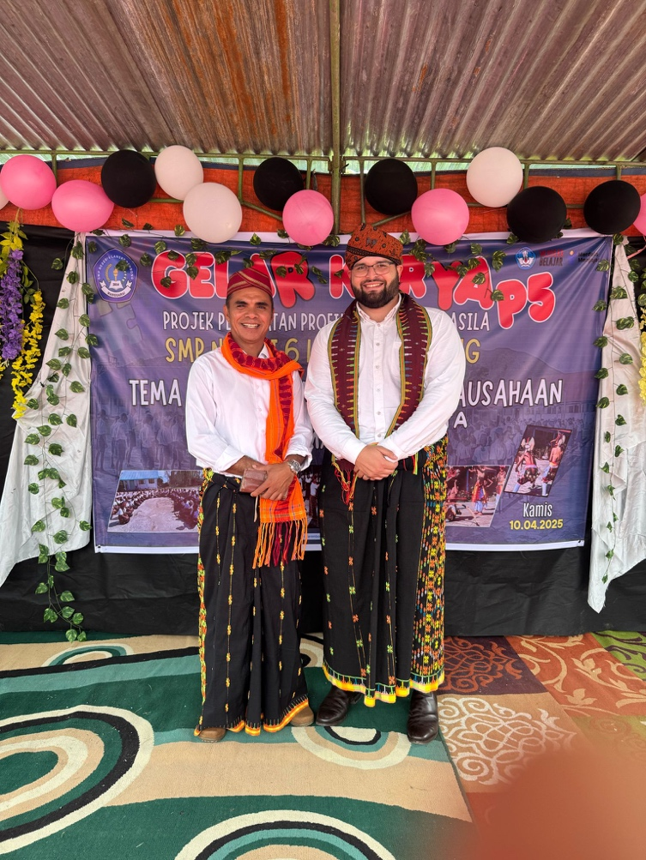

BRIDGE Grant Opportunities

Following participation in the BRIDGE Program, alumni will have the opportunity to apply for BRIDGE school partnership grants to support ongoing partnership activities.

BRIDGE Collaborative Projects Grant
Value: $5,000
The BRIDGE Collaborative Projects Grant aims to support partnerships in developing and facilitating global classroom programs that focus on:
- student engagement through peer collaboration and digital pedagogy, or
- professional learning with partner schools emphasizing Gender Equality, Disability, and Social Inclusion and Climate Change.
The BRIDGE Collaborative Projects Grants will be advertised annually through an online application process.

Lighthouse School Partnerships Grant
Value: $5000
The Lighthouse School Partnership Grant will identify and recognize high-performing BRIDGE partnerships by awarding them Lighthouse School status. This designation acknowledges outstanding educators and enables these schools to contribute to professional learning networks, host visiting dignitaries, and serve as role models for new and existing partnerships. Teachers from Lighthouse Schools will be appointed as BRIDGE Ambassadors, a new initiative for 2026 – 2029.
BRIDGE Ambassadors roles will include:
- supporting professional learning activities, as trainers/facilitators
- contributing to Professional Learning Network events, by sharing knowledge and experiences
- promoting the BRIDGE program to stakeholders and other BRIDGE schools

Next steps
Download the Australian School Application Form
Register for the Australian School Information Session
Duration: 1 hour
Session start time: 5:30pm AEST, 5:00pm ACST, 3:30pm AWST, 6:30pm AEDT
Dates: 16 February 2026, 17 February 2026, 18 February 2026
Registration Link: https://unimelb.zoom.us/meeting/register/GPznwCfOSpaYPJIzTB_dfA
Visi the website for more information: https://www.bridge-program.org/
Contact the team at: bridge@asialink.unimelb.edu.au
Applications close 13 March 2026






bridge@asialink.unimelb.edu.au
https://www.bridge-program.org/
Level 4, Sidney Myer Asia Centre, The University of Melbourne, Victoria 3010, Australia
+61 402 268 911

