
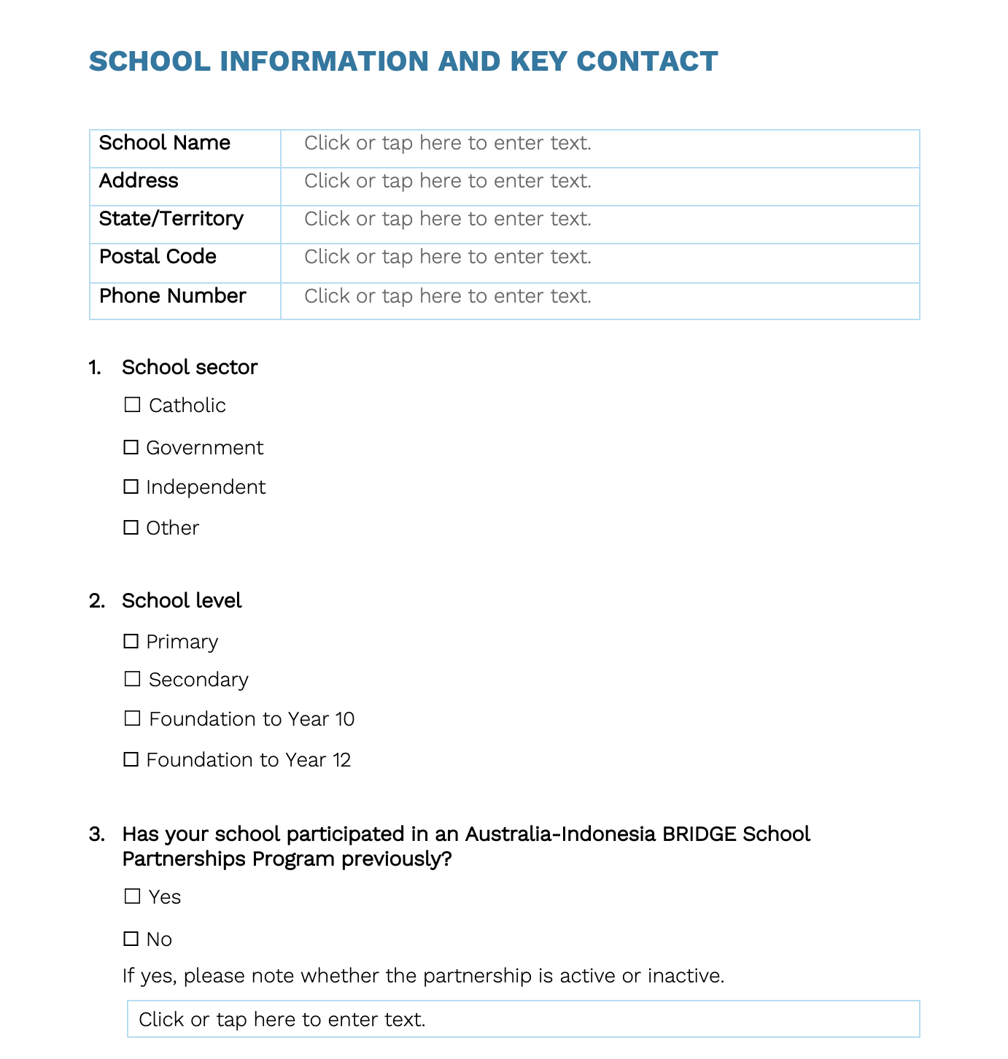z

AUSTRALIA-INDONESIA BRIDGE SCHOOL PARTNERSHIPS PROGRAM

Australian School Applications
SECTION 1: SCHOOL INFORMATION


The Australia-Indonesia BRIDGE School Partnerships Program is supported by the Australian Government Department of Foreign Affairs and Trade (DFAT) and implemented by Asialink Education at The University of Melbourne.

Australia-Indonesia BRIDGE School Partnerships Program

2027 Australia Indonesia BRIDGE School Partnership Program

This application form is for Australian schools that are applying to the 2027 Australia-Indonesia BRIDGE School Partnerships Program, funded by the Australian Government Department of Foreign Affairs and Trade and implemented by Asialink Education at the University of Melbourne. All sections must be completed for the application to be eligible.

Eligibility:
- Up to two educators are eligible to apply.
- One teacher for Alumni schools applying for a new partnership.
- As the application form has sections where sensitive personal information may be disclosed, we request that educators submit the application forms separately to preserve privacy.
- Schools must be from Queensland or Victoria for the 2027 program.
- The application form must be fully completed to be eligible to apply for the 2027 BRIDGE Program.

Key application documents:
Section 1 School Information
Section 2 School Leader Endorsement
Section 3 Teacher Information

Please upload completed application forms to: https://q.surveys.unimelb.edu.au/jfe/form/SV_d0wwmzEPrAyIAvk

Applications close: 10:00 pm Friday, 06 November 2026
Inquiries to be emailed to:
bridge@asialink.unimelb.edu.au

Indonesian schools that apply using this form will not be eligible for consideration.

SCHOOL AND KEY CONTACT INFORMATION

School Name | Click or tap here to enter text.
Address | Click or tap here to enter text.
State/Territory | ☐ Queensland ☐ Victoria
Postal Code | Click or tap here to enter text.
Phone Number | Click or tap here to enter text.

- School sector
☐ Catholic
☐ Government
☐ Independent
☐ Other

- School level
☐ Primary
☐ Secondary
☐ Foundation to Year 10
☐ Foundation to Year 12

- Has your school participated in an Australia-Indonesia BRIDGE School Partnerships Program previously?
☐ Yes
☐ No
If yes, please note whether the partnership is active or inactive.
Click or tap here to enter text.

- Does your school have any existing connections to Indonesia? (i.e. existing school partnership, student study tours, teaching Bahasa Indonesia, local diaspora, Indonesia content embedded across the curriculum).
Click or tap here to enter text.

SCHOOL SELECTION CRITERIA
Motivation and School Participation in the Program
(Maximum 250 words per question)

Please describe your school’s goals for participating and the benefits you expect to gain from the Australia–Indonesia BRIDGE School Partnerships Program. This information will be shared with an Indonesian partner school if selected to assist in matching. You may wish to highlight school vision, current activities, priorities, and programs of your school.
Click or tap here to enter text.

Please describe how your school will demonstrate sustained commitment to partnering with a school in Indonesia as part of the BRIDGE program
Click or tap here to enter text.

Please identify one way in which your school can promote collaboration with a prospective Indonesian partner school (minimum 100 words; maximum 250 words)
Click or tap here to enter text.

Please describe any initiatives, activities, or priorities for your school in promoting Gender Equality, Disability, and Social Inclusion (eg, school programs that support students with disabilities, demographic profile, professional learning programs, collaboration with allied health workers, respectful relationships programs etc)
Click or tap here to enter text.

The Australia-Indonesia BRIDGE School Partnerships Program is supported by the Australian Government Department of Foreign Affairs and Trade (DFAT) and implemented by Asialink Education at The University of Melbourne.

